**Assignment: Python Programming for DL**

Name: N Prajan Selvaraj

Register Number:192321071

Department:Btech IT

Date of Submission:17/07/24

**Problem 1: Real-Time Weather Monitoring System**

**Scenario:**

You are developing a real-time weather monitoring system for a weather forecasting company. The system needs to fetch and display weather data for a specified location.

**Tasks:**

1. **Model the data flow for fetching weather information from an external API and displaying it to the user.**
2. **Implement a Python application that integrates with a weather API (e.g., OpenWeatherMap) to fetch real-time weather data.**
3. **Display the current weather information, including temperature, weather conditions, humidity, and wind speed.**
4. **Allow users to input the location (city name or coordinates) and display the corresponding weather data.**

**Deliverables:**

* Data flow diagram illustrating the interaction between the application and the API.
* Pseudocode and implementation of the weather monitoring system.
* Documentation of the API integration and the methods used to fetch and display weather data.
* Explanation of any assumptions made and potential improvements.

# Solution:

# Real-Time Weather Monitoring System

# 1.Data Flow Diagram

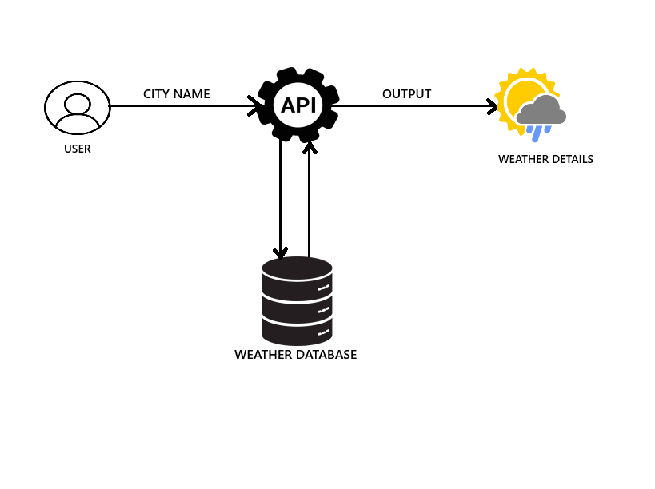

# 2. Implementation

|  |
| --- |
| import requests  api_key="bb9a4a1b490a74776edb2e83a7ae1f4b"  user_input=input("enter the city name:")  weather_data=requests.get(f"https://api.openweathermap.org/data/2.5/weather?q={user_input}&units=imperial&APPID={api_key}")  if weather_data.json()['cod']=='404':      print("no city found")  else:    weather=weather_data.json()['weather'][0]['main']    temp=round(weather_data.json()['main']['temp'])    print(f"the weather in {user_input} is {weather}")    print(f"the temperature in {user_input} is {temp}°F")    a=(temp-32)*5/9    print("temperature in celcius is",a) |

# 3.Display the Current weather information

enter the city name:chennai

the weather in chennai is Mist

the temperature in chennai is 82°F

temperature in celcius is 27.77777777777778

**5.Documentation**

# 